***Wireshark Essentials: Network Traffic Analysis for Educational Purposes***

**Task 1: Intercepting unencrypted HTTP traffic**

- First of all I launched **Wireshark**, selected the network interface I am using i.e. Wi-Fi.

- in the filter field I entered **http** and clicked **Apply**

- I accessed an unsecured site, for example **httpforever.com**

- I analyzed the captured **HTTP** traffic with Wireshark and found unencrypted data such as the **GET** request header.

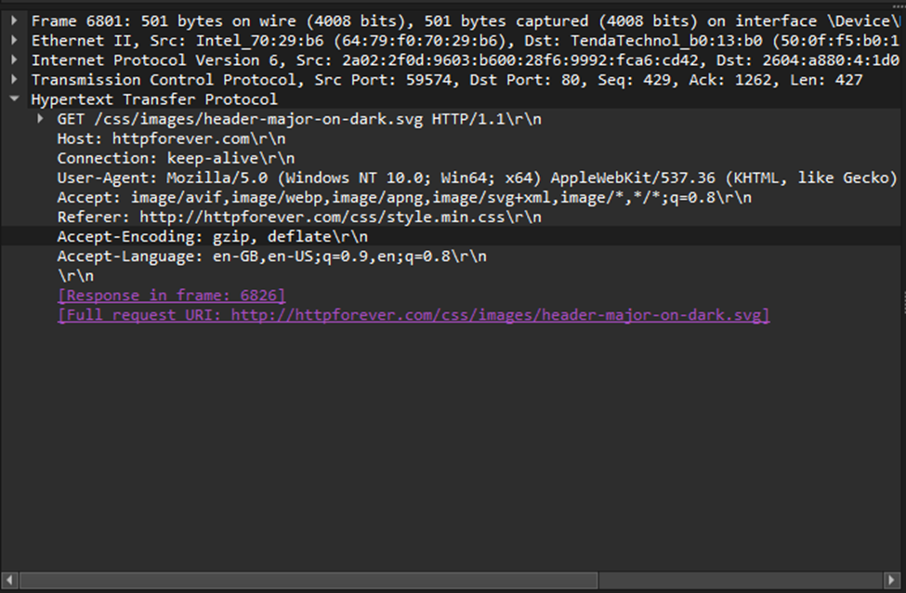

**Task 2: Analyze SMTP traffic to identify email vulnerabilities**

- I tried all possible methods but unfortunately failed.

**Task 3: Identify unexpected activity on your own network**

- first I opened **Wireshark** and selected the network interface I use(Wi-Fi)

- in the filter field I entered the command **ip.src==my_ip_address** and pressed **Apply.**

- I analyzed the traffic and failed to identify any suspicious activity on the network.

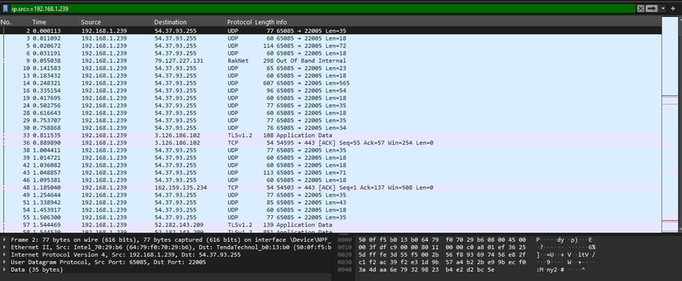

**Sarcina 4: Găsirea în traficul interceptat a unui login și a unei parole**

- am lansat **Wireshark** și am selectat interfața de rețea folosită(**Wi-Fi)**

- am început interceptarea traficului.

- am accesat site-ul<http://testphp.vulnweb.com/> după care am dat sign up.

- am oprit interceptarea și am început analiza acestuia.

